

AMAZING WEALTH BUILDERS WEBSITE:

WEBSITE THEME:
Amazing Wealth builders is a coaching and strategy company, lead by David & Leah Cupps. We help entreprenuers realize their dreams of achieving wealth through eCommerce.

WEBSITE THEME:
Colors – Navy & Silver
Logo – The logo includes a ‘knight’ chess piece. This represents that we are ‘strategists’ trying to wine the game of wealth

IMAGES:
We are looking for images that look high-end and bolster a ‘wealthy’ look. Great images to support our ideas, include:
- Chess pieces
- Chess board
- Mountains, hikers

*All images should be black, navy, grey and have a monochromatic look to them.

FOR MORE IMAGES: YOU CAN GO TO WWW.AMAZINGLIFEBUILDERS.COM FOR MORE IMAGES OF DAVID AND LEAH AT CONFERENCES, SPEAKING ENGAGEMENTS, ETC.

PAGES ON SITE:
- Home
- About
- Media
  - Interviews & Podcasts
  - Events
- Courses
- Contact

HOME PAGE CONTENT:

SECTION 1.0 SLIDER
Home page slider: The quickest way to build wealth, is through growing and selling your business.
Call to action: Found out how we did it
{USE IMAGES LIKE THOSE HIGHLIGHTED ABOVE)

SECTION 2.0 CAPABILITIES

- Background
Serial entrepreneurs, David and Leah have built multiple 7figures businesses. Focusing their effort in the Amazon FBA space has given them massive success and the ability to scale their businesses quickly.

- Experience
David & Leah have created and successfully sold multiple Amazon businesses. Selling across multiple categories and building brands from the ground up, even after they exited their business, demonstrates that their strategies work.

- Leadership
Often featured on Podcasts and on Stage, David and Leah believe giving back is an important part of living an Amazing Life. They want to inspire new entrepreneurs on ways they can achieve an amazing level of freedom in their personal and work life.

- Their Story
David & Leah’s story of starting their business with just $500 for inventory and scaling that to a multiple 7-figure businesses in just a few years has been a sensational story in the Amazon selling community. They believe that sharing their story can inspire others to do the same.

SECTION 3.0 Call to Action:
Want to work directly with David & Leah? Find out How >

SECTION 4.0 ABOUT DAVID & LEAH
David and Leah Cupps are a dynamic eCommerce powerhouse. They have created, scaled and sold multiple Amazon brands, each for a 7-figure exit. When they are not scaling a eCommerce new brand, they offer coaching and consulting entreprenuers.

USE THIS PHOTO:

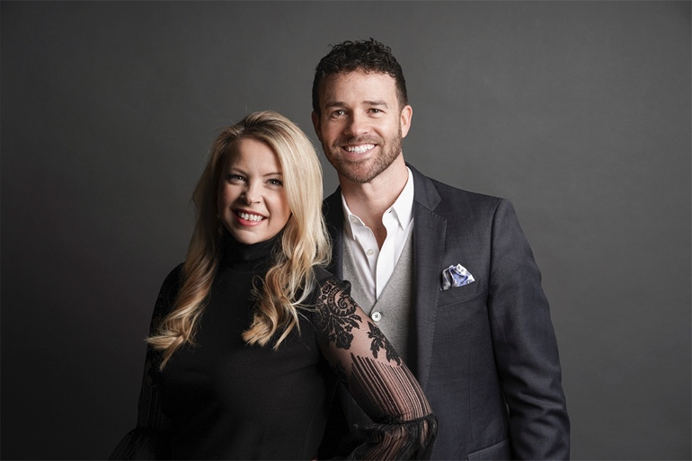

SECTION 5.0 TESTMONIALS
{ Add a placeholder here for VIDEO } + a quote area from a customer.

SECTION 6.0 CONTACT AREA
- Facebook
- Email sign up
- Email address
- SITE MAP
- PAGES

